# RETAIL MANAGEMENT APPLICATION

**SALESFORCE NAAN MUDHALVAN PROJECT REPORT**

***Submitted By***

## GIRIHARAN S (611220244008) HARI PRASANNA S (611220244010) NANDHAKUMAR S (611220244025) NITHISH S (611220244027) MURALIDHARN S (611220244024)

***in partial fulfilment for the award of the***

***degree of***

## BACHELOR OF TECHNOLOGY

***in***

**COMPUTER SCIENCE AND BUSINESS SYSTEMS**

**KNOWLEDGE INSTITUTE OF TECHNOLOGY,**

**SALEM-637504**

## BONAFIDE CERTIFICATE

Certified that this project report titled **“RETAIL MANAGEMENT APPLICATION”** is the BonafIde work of **“ GIRIHARAN S(611220244008), HARI PRASANNA S**

**(611220244011), NANDHAKUMAR S(611220244025), NITHISH S (611220244027), MURALIDHARAN S(611220244024)”** who carried out the project work under my supervision.

**SIGNATURE SIGNATURE**

Dr.M. RAMKUMAR M.E., Ph.D., Mr. B.VENKATARAMANAN M.E.,

**HEAD OF THE DEPARTMENT FACULTY MENTOR**

**PROFESSOR ASSISTANT PROFESSOR** Department of Computer Science Department of Computer Science and Business Systems, and Business Systems,

Knowledge Institute of Technology, Knowledge Institute of Technology,

Kakapalayam, Kakapalayam,

Salem- 637 504. Salem- 637 504.

---------------------------------------------------- ------------------------------------------------------------

**SPOC HEAD OF THE DEPARTMENT**

## ACKNOWLEDGEMENT

At the outset, we express our heartfelt gratitude to **GOD,** who has been our strength to bring this project to light.

At this pleasing moment of having successfully completed our project, we wish to convey our sincere thanks and gratitude to our beloved president **Mr. C. Balakrishnan,** who has provided all the facilities to us. We would like to convey our sincere thanks to our beloved Principal **Dr. PSS. Srinivasan,** for forwarding us to do our project and offering adequate duration in completing our project.

We express our sincere thanks to our Head of the

Department **Dr. M. Ramkumar,** Department of Computer Science and Business Systems for fostering the excellent academic climate in the Department.

We express our pronounced sense of thanks with deepest respect and gratitude to our Faculty Mentor **Mr.B.VENKATARAMANAN,**

Department of Computer Science and Business Systemsfor their valuable and precious guidance and for having amicable relation.

With deep sense of gratitude, we extend our earnest and sincere thanks to our SPOC **Mr. T. Karthikeyan,** Assistant Professor, Department of Computer Science and Engineering for his guidance and encouragement during this project.

We would also like express our thanks to all the faculty members of our Department, friends and students who helped us directly and indirectly in all aspects of the project work to get completed successfully.

# TABLE OF CONTENTS

|  |  |  |
| --- | --- | --- |
| **CHAPTER**  **NO.** | **TITLE** | **PAGE NO.** |
| **1** | **INTRODUCTION** |  |
| **2** | **PROJECT SPECIFICATIONS** |  |
|  | 2.1 Project Goal |  |
|  | 2.2 Project Scope |  |
|  | 2.3 Technical Requirements |  |
|  | 2.4 Functional Requirements |  |
| **3** | **PREPARATION DATA MODELING** |  |
| **4** | **USERS & DATA SECURITY** |  |
| **5** | **AUTOMATION** |  |
| **6** | **REPORTS & DASHBOARD** |  |
|  | GitHub & Project Video Demo Link |  |

# 1.INTRODUCTION

Salesforce, a leading cloud-based Customer Relationship Management (CRM) platform, is a pivotal tool for organizations to manage customer data, optimize sales processes, and elevate customer interactions. Its multifaceted features include Sales Cloud, which enhances sales management through lead tracking, opportunity management, and seamless email integration. Service Cloud focuses on exceptional customer support, featuring case management, knowledge base development, and multi-channel support. Marketing Cloud empowers businesses with marketing automation, email campaigns, social media engagement, and in-depth analytics. Salesforce's hallmark is its customizability, allowing businesses to tailor the platform to meet specific requirements, while robust integration capabilities facilitate seamless connections with other business applications.

The platform equips businesses with powerful reporting and analytics tools, enabling data-driven decisions and insightful, customized reports and dashboards. Salesforce ensures mobile accessibility, enabling users to stay connected and productive while on the move. A paramount emphasis on data security and compliance guarantees data protection and privacy. Whether you're a small start-up or a large enterprise, Salesforce offers scalability to accommodate your evolving needs.

Through Salesforce, organizations foster improved customer relationships, increased sales efficiency, and superior customer support. It empowers businesses to make data-driven decisions, streamline operations, and create impactful, targeted marketing campaigns. This introduction encapsulates Salesforce's capabilities and benefits, offering a concise overview for your project document, allowing for a better understanding of how the platform can contribute to your specific project goals.

# 2.PROJECT SPECIFICATIONS

**2.1 Project Goal** Retailing encompasses the business activities involved in selling goods and services to consumers for their personal, family, or household etc. A CRM product owner has requested to create two applications, one is a sales app for sales reps to use this application and store customers data, and the second application is a service app for service reps/agents to provide support to customers in dealing cases. To generate business on top of the customers.

## 2.2 Project Scope

.

* **Object Creation (Milestone 1):** Custom objects and relationships will be defined to efficiently store and manage data related to Warehouse, Sales order and other relevant information.
* **Tabs Creation (Milestone 2):** Tabs will be configured to provide user-friendly access to different sections and functionalities within the CRM application.
* **Lightning App (Milestone 3):** The CRM application will be created, and it will serve as the central hub for managing application function by working together as a unit.
* **Fields & Relationships (Milestone 4):** Custom fields and relationships will be established to capture specific data attribute values that are required for a particular object in a record.
* **Users (Milestone 5):** A user is anyone who logs in to Salesforce. Users are employees at your company, such as sales reps, managers, and IT specialists, who need access to the company's records. Every user in Salesforce has a user account.
* **Validation Rules (Milestone 6):** As a crm product owner they requested to create a validation rule on account object on the phone field.It verify that the data a user enters in a record meets the standards you specify before the user can save the record
* **User Adoption (Milestone 7):** Strategies and tools will be implemented to encourage user adoption and make the application user-friendly.
* **Reports (Milestone 8):** Custom reports will be created to track and analyse data, providing valuable insights for users.
* **Dashboards (Milestone 9):** Dashboards will be designed to display key performance indicators and visual summaries of application data.
* **Flows (Milestone 10):** Flow is the most powerful automation tool. It can be trigger for record insert, update and. record delete and it can be run for both after and before events
* The project aims to create a A CRM product owner has requested to create two applications, one is a sales app for sales reps to use this application and store customers data, and the second application is a service app for service reps/agents to provide support to customers in dealing cases. To generate business on top of the customers.

## 2.3 Technical Requirements

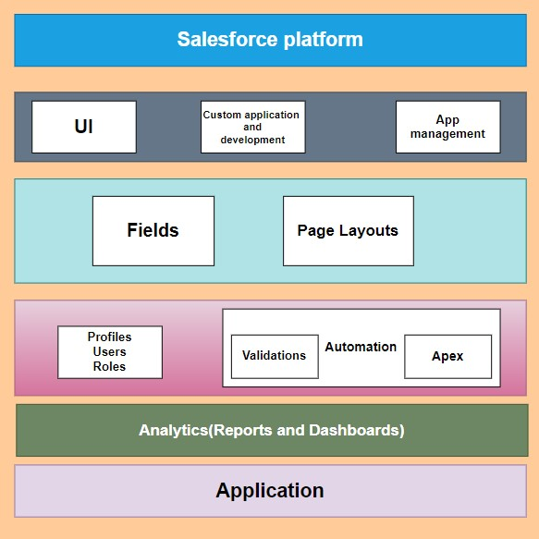

## 2.4 Functional Requirements

**Customer Management**: Create and manage customer profiles. Track customer purchase history and preferences. Implement loyalty programs and rewards.

**Inventory Management**: Maintain a database of products, including descriptions, prices, and quantities. Handle stock levels, reordering, and alerts for low inventory. Integrate with barcode scanners for efficient stock management.

**Sales Order Processing**: Create and process sales orders. Generate invoices and receipts. Handle returns and refunds.

**Point of Sale (POS):**

Implement a user-friendly POS system for in-store sales. Process payments, including cash, card, and digital payments. Issue receipts and track real-time sales data.

**E-commerce Integration:** Integrate with e-commerce platforms for online sales. Synchronize product catlaog, pricing, and inventory.

**Multi-Channel Sales**: Support sales across various channels, including brick-and-mortar stores, online, and mobile apps.

**Reporting and Analytics**: Generate sales reports, including sales by product, store, and region. Provide real-time analytics to help with decision-making.

**Employee Management:**Manage employee schedules and time tracking. Track employee performance and incentives.

**Supplier Management**: Maintain a database of suppliers and their products. Automate purchase order creation.

**Customer Support and CRM**: Implement customer support features.

Integrate with customer relationship management tools.

**Inventory Forecasting**: Use data analytics to predict inventory needs.

Minimize overstock and understock situations.

**Security and Compliance**: Ensure data security and compliance with industry regulations.

**Integration with Payment Gateways**: Support various payment gateways and ensure secure transactions.

**Mobile Accessibility:** Provide mobile access for on-the-go management.

**User Permissions and Roles:** Define roles and permissions for different users to control access to sensitive data.

**Marketing and Promotions:** Implement marketing campaigns, discounts, and promotions.

**Localization:** Support multiple languages, currencies, and tax regulations for global retail operations.

**Feedback and Reviews:** Collect and manage customer feedback and reviews.

**Returns and Refunds Management:** Handle returns and refunds efficiently, including inventory adjustments.

**Third-Party Integrations:** Integrate with third-party systems for accounting, shipping, and more

# 3.PREPARATION DATA MODELING

**Objects:**

Salesforce objects are database tables that permit you to store data that is specific to an organization. It consists of fields (columns) and records (rows).

Salesforce objects are of two types:

1.Standard Objects: Standard objects are the kind of objects that are provided by salesforce.com such as users, contracts, reports, dashboards, etc.

2.Custom Objects: Custom objects are those objects that are created by users. They supply information that is unique and essential to their organization. They are the heart of any application and provide a structure for sharing data.

In This Application We Use 4 Custom Objects:

1.Warehouse

2.Sales order

3.Dispatch/Tracking

4.Dispatch/Delivery

**1)Create A Custom Object for Warehouse:**

1.From setup click on object manager.

2.Click create, select custom object.

3.Fill in the label as " Warehouse ".

4.Fill in the plural label as " Warehouse s".

5.Record name: " Warehouse Name"

6.Select the data type as "Text".

7.In the Optional Features section, select Allow Reports .

8.In the Search Status section, select Allow Search.

9.In the Object Creation Options section, select Add Notes and Attachments related list to default page layout.

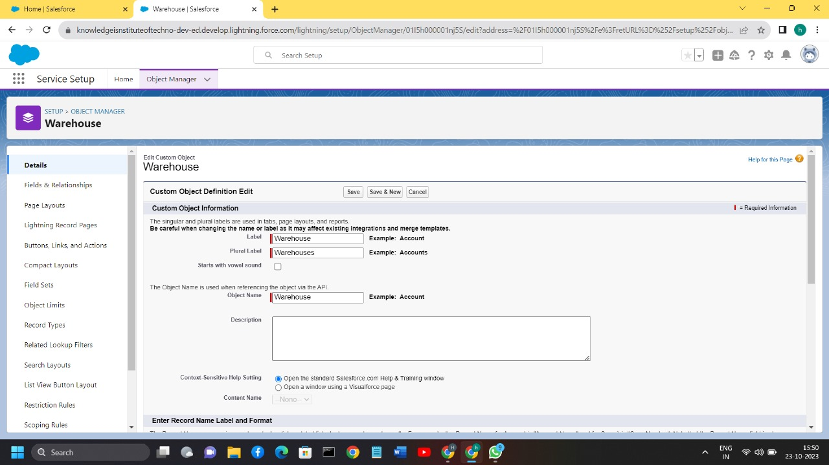

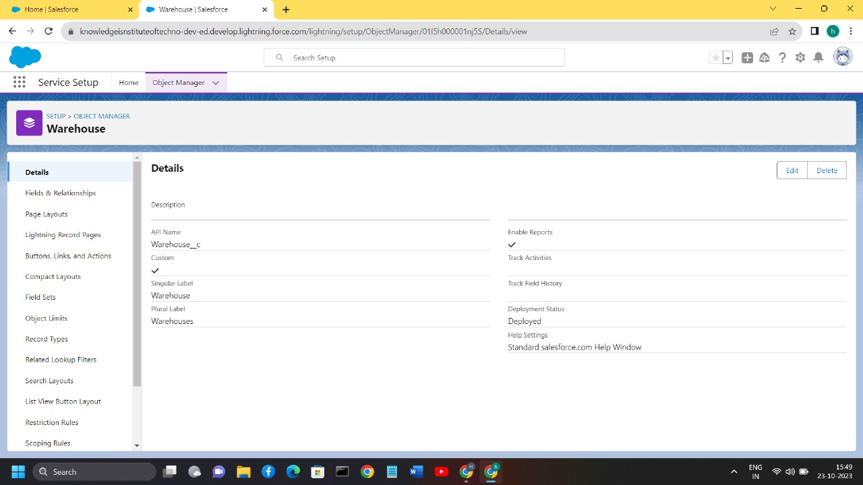

10.Leave everything else as is, and click Save.

## 2)Creation of Jobs Object

1.Click on the gear icon and then select Setup.

2.Click on the object manager tab just beside the home tab.

3.After the above steps, have a look on the extreme right you will find a Create Dropdown click on that and select Custom Object.

4.On the Custom Object Definition page, create the object as follows:

5.Label: Sales order

6.Plural Label: Sales orders

7.Record Name: Sales Name

8.Select the data type as "Text".

9.Check the Allow Reports checkbox

10.Check the Allow Search checkbox

11.In the Object Creation Options section, select Add Notes and Attachments related list to default page layout 12.Click Save.

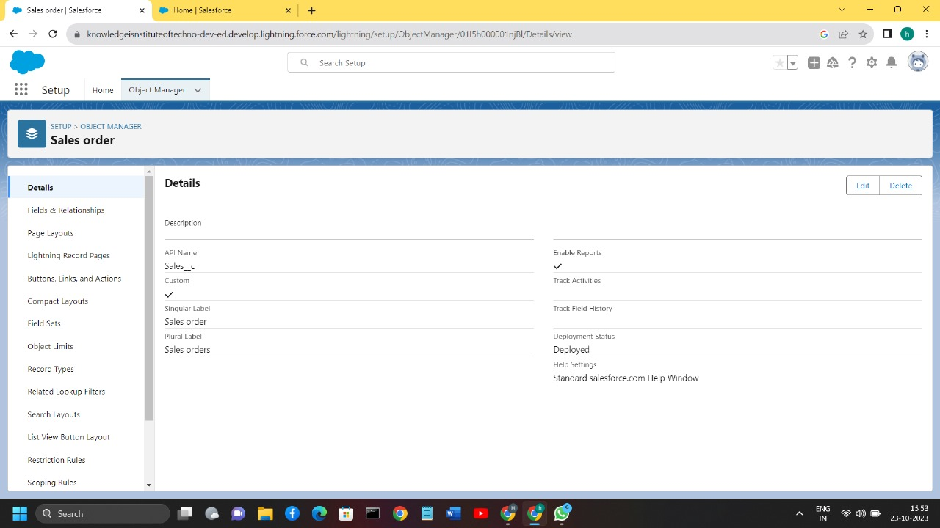

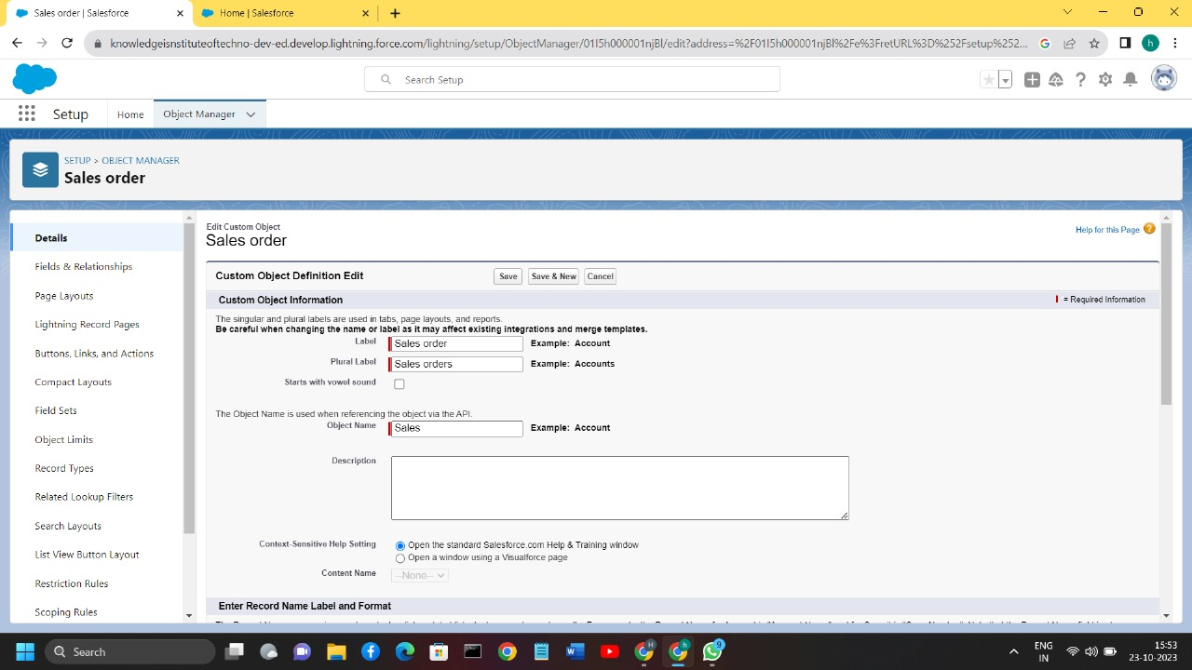

## 3)Creation of Dispatch/Tracking Object

1.Click on the gear icon and then select Setup.

2.Click on the object manager tab just beside the home tab.

3.After the above steps, have a look on the extreme right you will find a Create Dropdown click on that and select Custom Object.

4.On the Custom Object Definition page, create the object as follows:

5.Label: Dispatch/Tracking

6.PluralLabel: Dispatches/Trackings

7.Record Name: dispatch Name

8.Select the data type as "Text".

9.Check the Allow Reports checkbox.

10.Check the Allow Search checkbox.

11.In the Object Creation Options section, select Add Notes and Attachments related list to default page layout. 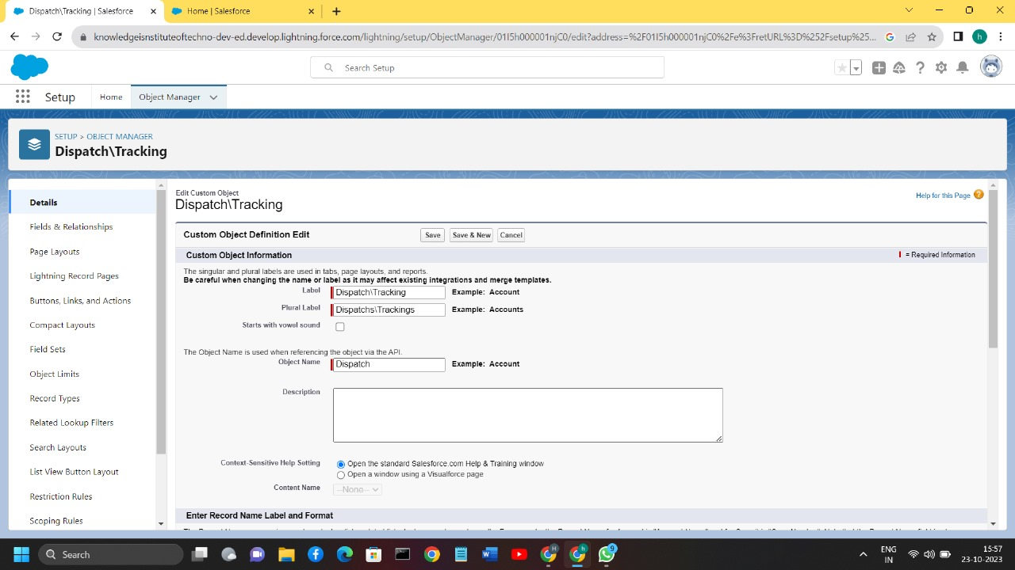

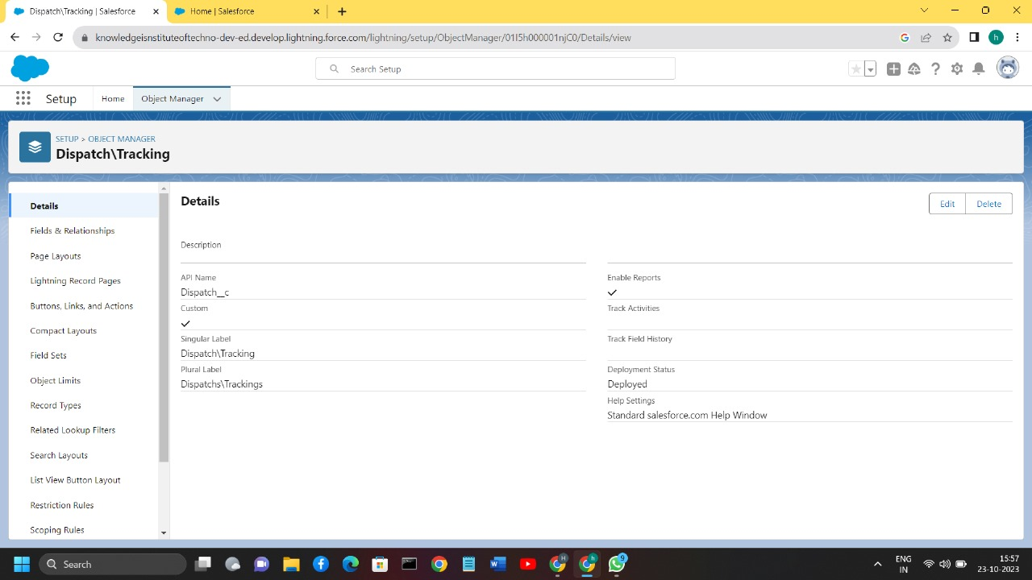12.Click Save.

## 4)Creation of Dispatch/Delivery Object

1.Click on the gear icon and then select Setup.

2.Click on the object manager tab just beside the home tab.

3.After the above steps, have a look on the extreme right you will find a Create Dropdown click on that and select Custom Object.

4.On the Custom Object Definition page, create the object as follows:

5.Label: Dispatch/Delivery

6.Plural Label: Dispatches/Deliveries

7.Record Name: Dispatch/Delivery Number

8.Select the data type as "Auto Number".

9.Under display format enter "JP- {0000}"

10.Enter starting number as 1 11.Check the Allow Reports checkbox.

12.Check the Allow Search checkbox.

13.In the Object Creation Options section, select Add Notes and Attachments related list to default page layout.

14.Click Save.

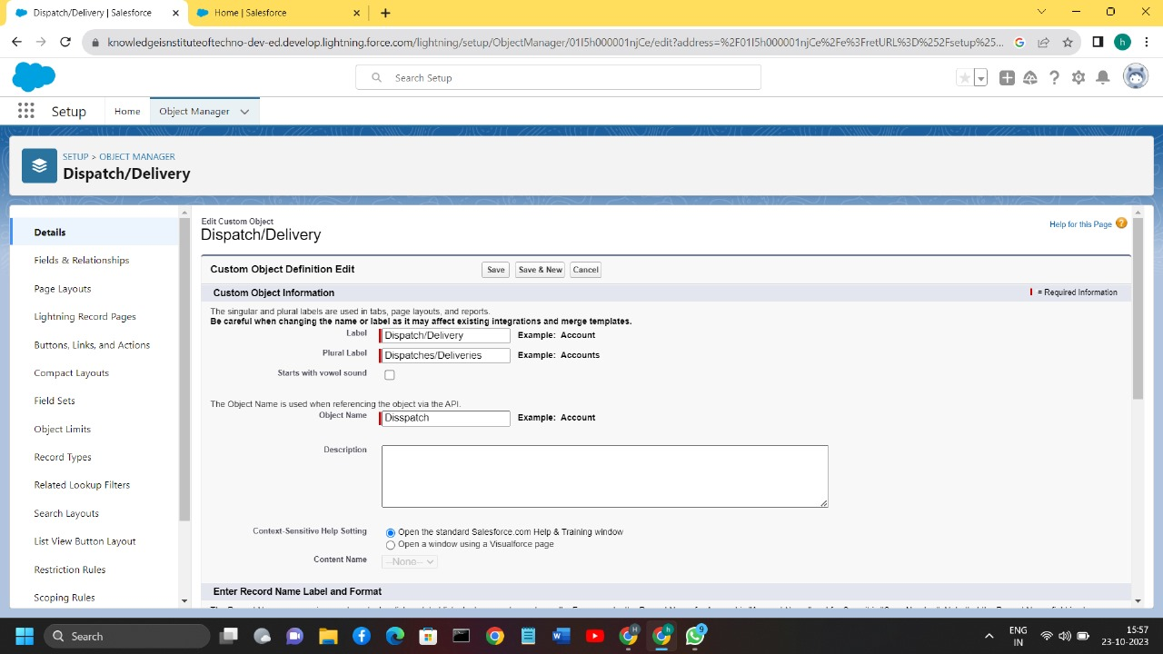

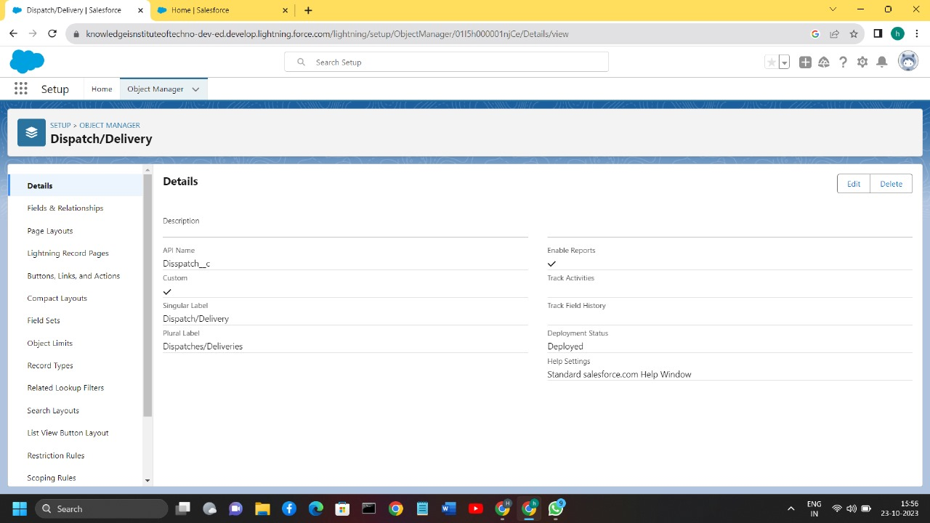

**Tabs:**

Tabs in Salesforce help users view the information at a glance. It displays the data of objects and other web content in the application.

There are mainly 4 types of tabs:

1.**Standard Object Tabs:** Standard object tabs display data related to standard objects.

2.**Custom Object Tabs:** Custom object tabs display data related to custom objects. These tabs look and function just like standard tabs.

3.**Web Tabs:** Web Tabs display any external Web-based application or Web page in a Salesforce tab.

4.**Visualforce Tabs:** Visualforce Tabs display data from a Visualforce Page.

## 1)Creation of Tab Warehouse

1.Now create a custom tab.

2.Click on Home tab, enter Tabs in Quick Find and select Tabs.

Under custom object tabs, click New

3.For Object, select Warehouse.

4.For Tab Style, select any icon.

5.Leave all defaults as is. Click Next, Next, and Save.

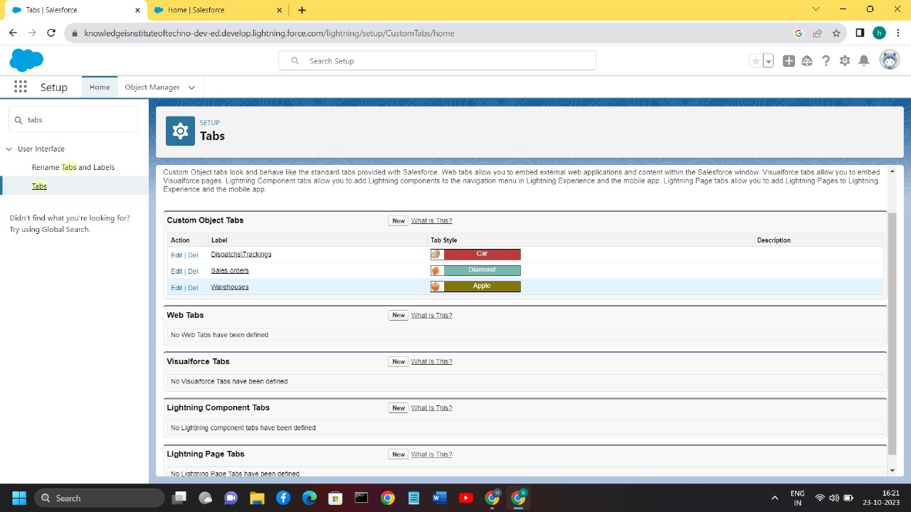

## 2)Creation of Sales order Tab

1.Now create a custom tab.

2.Click on Home tab, enter Tabs in Quick Find and select Tabs.

3.Under custom object tabs, click New.

4.For Object, select Sales order.

5.For Tab Style, select any icon.

6.Leave all defaults as is. Click Next, Next, and Save.



## 3)Creation of Dispatch/Tracking Tab

1.Now create a custom tab.

2.Click on Home tab, enter Tabs in Quick Find and select Tabs.

3.Under custom object tabs, click New.

4.For Object, select Dispatch/Tracking.

5.For Tab Style, select any icon.

6.Leave all defaults as is. Click Next, Next, and Save



**Lightning App:**

Apps in Salesforce are a group of tabs that help the application function by working together as a unit. It has a name, a logo, and a particular set of tabs. The simplest app usually has just two tabs.

There are 2 types of Salesforce applications:

**Standard apps:** these apps come with every occurrence of

Salesforce as default. Community, Call Centre, Content, Sales, Marketing, Salesforce Chatter, Site.com, and App Launcher are included in these apps. The description, logo, and label of a standard app cannot be altered.

**Custom apps:** these apps are created according to the needs of a company. They can be made by putting custom and standard tabs together. Logos for custom apps can be changed.

1.Click New Lightning App. Job Application Tracking as the App Name, then click Next

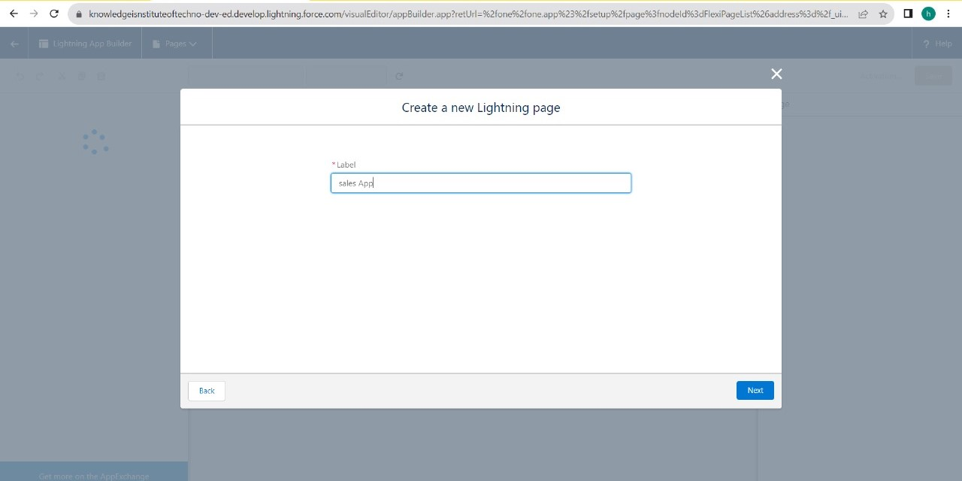

4. Under App Options, leave the default selections and click Next.

5. Under Utility Items, leave as is and click Next. 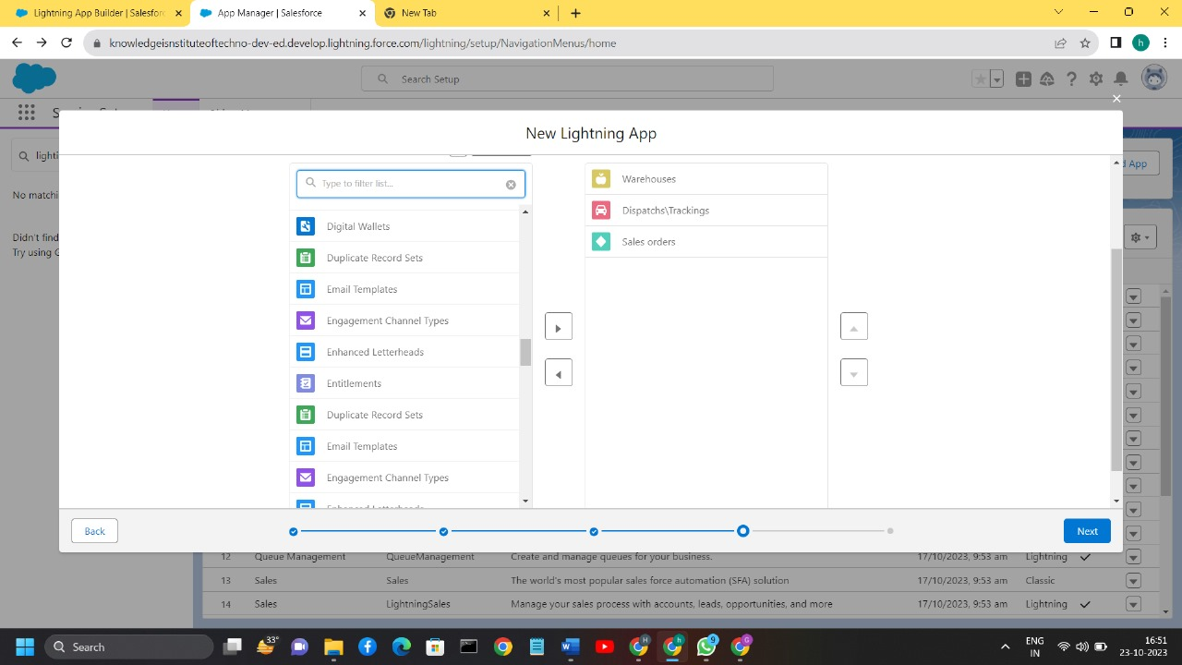

6. From Available Items, select Campaign, Leads, Accounts, Contacts, Opportunities, Products, Warehouse, Sales order, Dispatch/Tracking, Reports, and Dashboards and move them to Selected Items. Click Next.

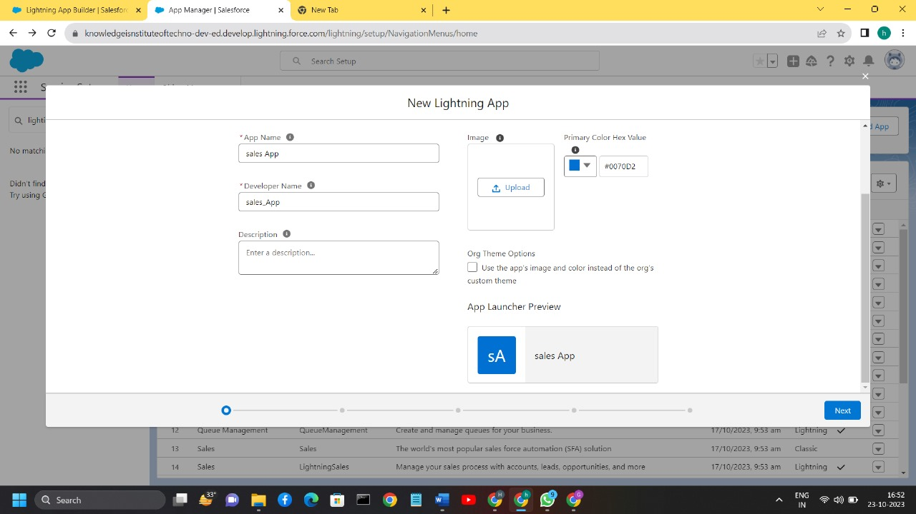

7. From Available Profiles, select System Administrator and move it to

Selected Profiles. Click Save & Finish

**Fields and Relationship:**

Fields in Salesforce represent what the columns represent in relational databases. It can store data values which are required for a particular object in a record.

There are 2 types of fields in salesforce:

**Standard fields:** There are four standard fields in every custom object that are Created By, Last Modified By, Owner, and the field created at the time of the creation of an object. These fields cannot be deleted or edited and they are always required. For standard objects, the fields which are present by default in them and cannot be deleted from standard objects are standard fields.

**Custom fields:** The Custom fields which are added by the administrator/developer to meet the business requirements of any organization. They may or may not be required. **1)Creation of Fields for The Dispatch/Tracking**

1.click the gear icon and select Setup. This launches Setup in a new tab.

2.Click the Object Manager tab next to Home.

3.Select Dispatch/Tracking.

4.Select Fields & Relationships from the left navigation, and click

New

5.Choose the data type as Text, click next

6.For Field Label, enter Tracking ID & length = 40

7.Next, Next and Click save.

8. Now let's create the other fields and we must choose the data types of the fields carefully. Let’s have a look at it. Similarly create fields for Warehouse object- Address, Location select datatype according table. Similarly create fields for Dispatch/Delivery object- Dispatched, Expected date of delivery select datatype according table

9.Click Next, Next, then Save & New.

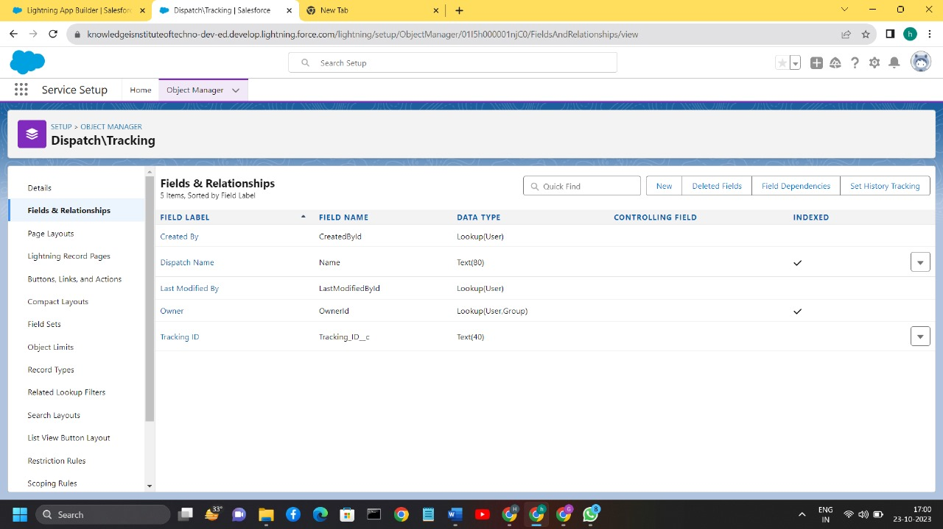

## 2)Creation of Fields for The Warehouse Objects

1.Select the Location as the Data Type, then click Next.

2.For Field Label as Address Click Next, Next, then Save & New

3.Select the Address as the Data Type, then click Next. For Field Label, Location Description.

4.Click Next, Next, then Save & New.

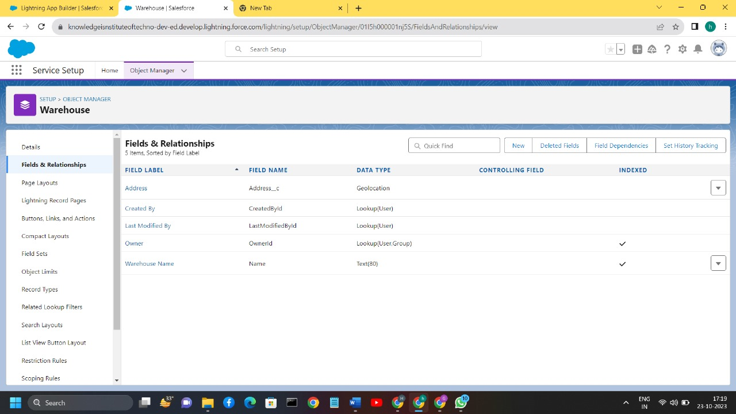

## 3)Creation of Dispatch/Delivery for Job Object

1.From Setup, go to Object Manager

2.On the sidebar, click Fields & Relationships.

3.Click New.

4.Choose Dispatch/Delivery and click Next

5.Choose the datatype as date and select the label name Expected date.

6. Click Next, Next, then Save

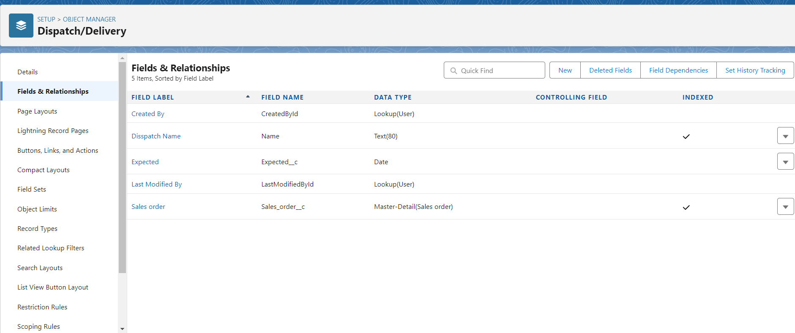

## 4)Master detail relationship Dispatch /Delivery

Let's create a master-detail relationship on Dispatch/Delivery object.

1.Select Master-Detail Relationship as the Data Type and click Next.

2.For Related to, enter Sales order.

3.Click Next.

4.For Field Label, enter Sales order.

5.Click Next, Next, Next and Save.

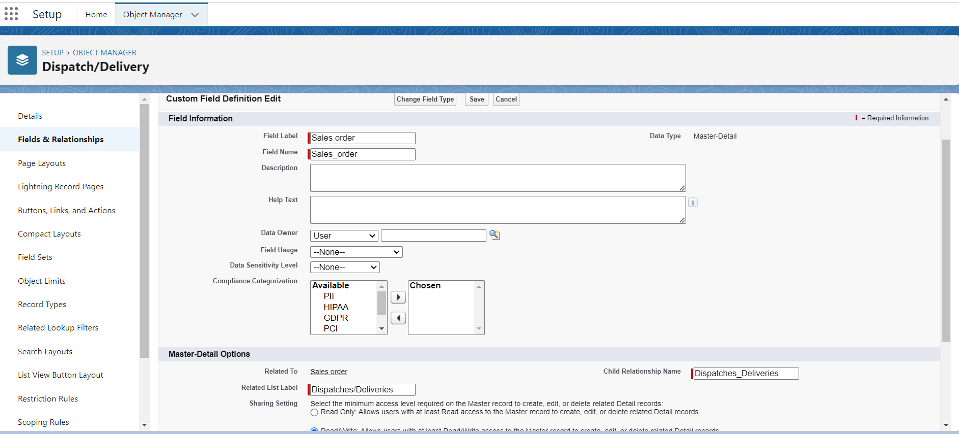

## 5)Create Picklist Fields on Sales order

1.From Setup, click Object Manager and select Sales order.

2.Click Fields & Relationships, then New.

3.Select Picklist as the Data Type and click Next.

4.For Field Label enter Status

5.Select Enter values, with each value separated by a new line and enter these values:

6.Open,Hold,Shipped,Returned

7.Click Next, Next, then Save & New

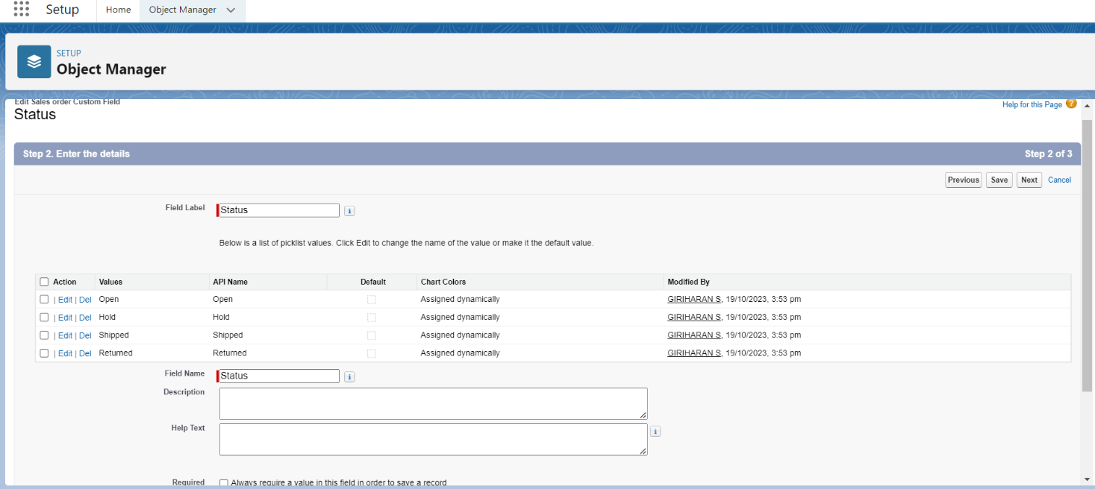

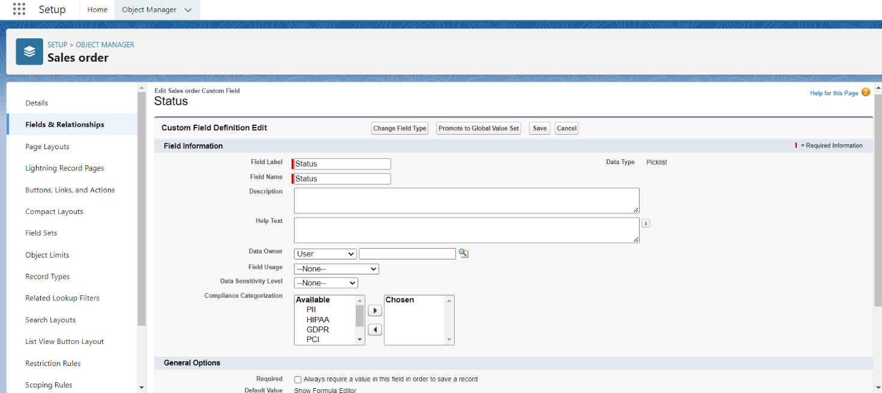

## 6)Lookup Relationship

1.Select look up Relationship as the Data Type and click Next.

2.For Related to, enter Account.

3.Click Next.

4.For Field Label, enter Customer.

5.Click Next, Next, Next and Save.

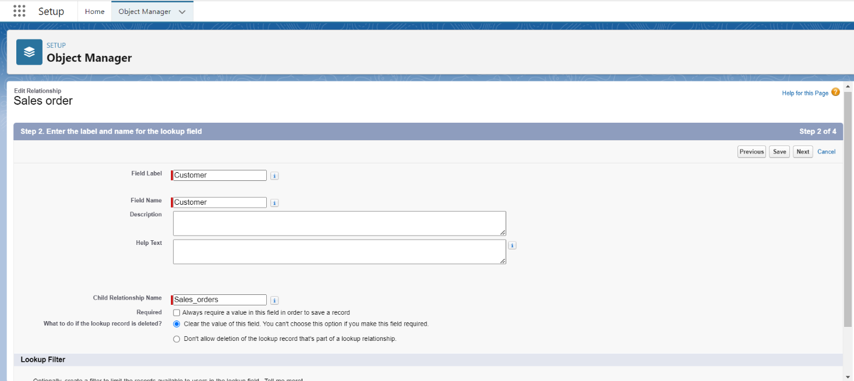

6.Click lookup filter.

7.Provide filter as given below & also refer picture (Screenshot of Step Contact: Account ID equals Sales Order: Customer)

8.ClickNext,Next,NextandSave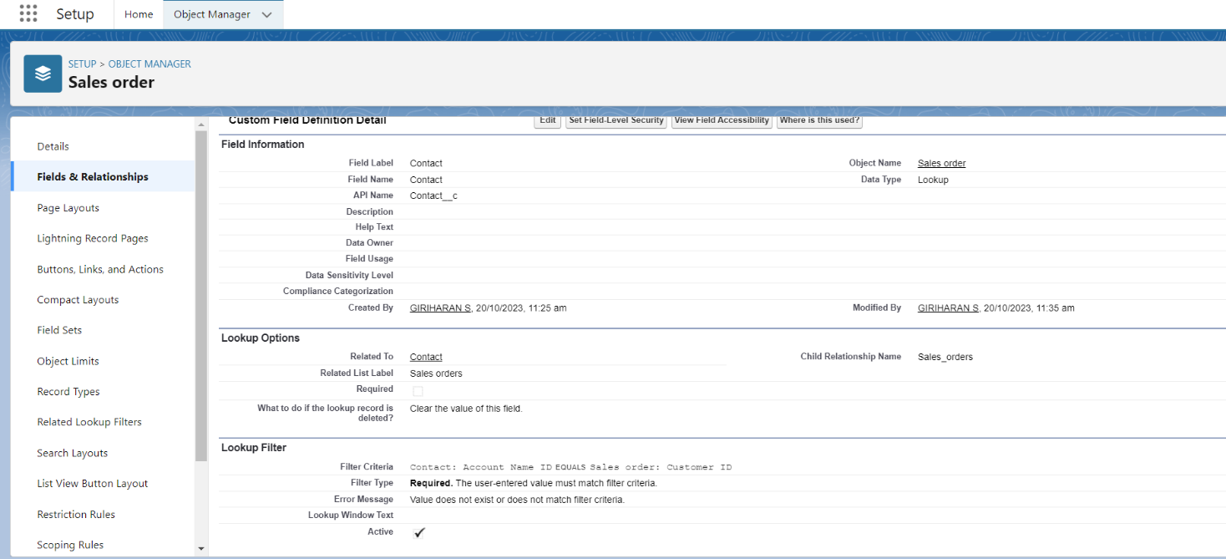

## 7)Create Field Dependency (On Candidate Object)

1.Create a dependency between these two picklists, so that when a state is selected, only respective Values are available.

2.The below steps will assist you in creating Field Dependencies.

3.Click on the gear icon and then select Setup.

4.Click on the object manager tab just beside the home tab.

5.After the above steps, Select Candidate Object

6.Now Select Fields and relationships from setup menu of the Candidate object.

7.Click Field Dependencies.

8.Click New.

9.Select State as the Controlling Field and select City as the Dependent Field.

10.Click Continue.

11.Select the appropriate Value in each column by double-clicking them. For Ex. Rajasthan - Jaipur

12.Click Include Values. And it is also same for UP, MP& Punjab with its city.

13.Click Preview, then test the dependency by selecting different State and viewing the associate Values available for Particular state.

14.Click Close to close the preview window.

15.Click Save.

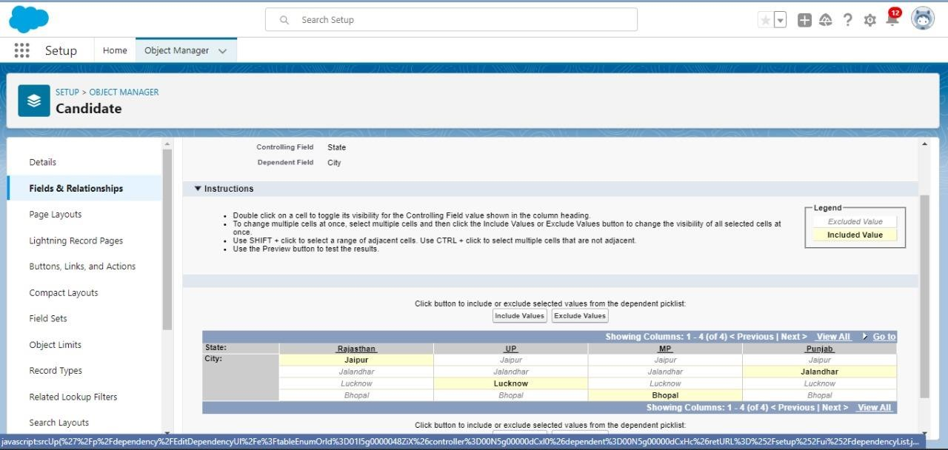

## 8)Cross-Object Formula Field

Cross-object formula field- A cross-object formula field is basically a formula field. A cross-object formula can reference merge fields from a master (“parent”) object if an object is on the detail side of a master-detail relationship. A cross-object formula works with Lookup relationships as well as in Master detail relationship. You can reference fields from objects that are up to 10 relationships away. Creation of cross object formula field

1.Select your object from object selection has Contact.

2.Select the option fields and relationships.

3.That will navigate to enter the details page where you give the field label.

4. Give the label name has Account Website

5.Select formula return type Text

6.In the formula field enter this formula Account. Website.

7.Click next you will navigate to field level security click on visible checkbox so that it is visible to all profiles.

8.Select the next option, select the page layout and save it.

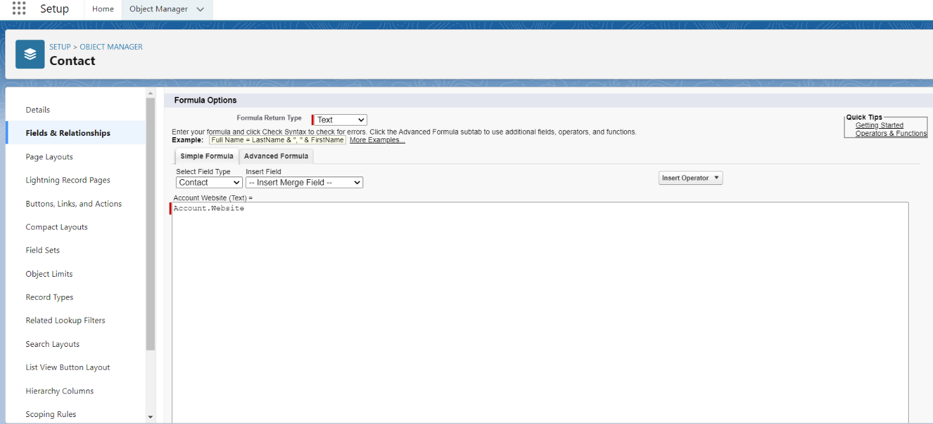

# 4.USER & DATA SECURITY

## User

A user is anyone who logs in to Salesforce. Users are employees at your company, such as sales reps, managers, and IT specialists, who need access to the company's records. Every user in Salesforce has a user account. The user account identifies the user, and the user account settings determine what features and records the user can access.

## 1)To Create A User

1.From Setup, enter Users in the Quick Find box, then select Users.

2.Click New User.

3.Enter First name as Giriharan and last name as S.

4.Enter the user’s name and email address and a unique username in the form of an email address. By default, the username is the same as the email address.

5.Select user License as Salesfoce Platform User.

7.Select profile (salesforce).

8.Click save 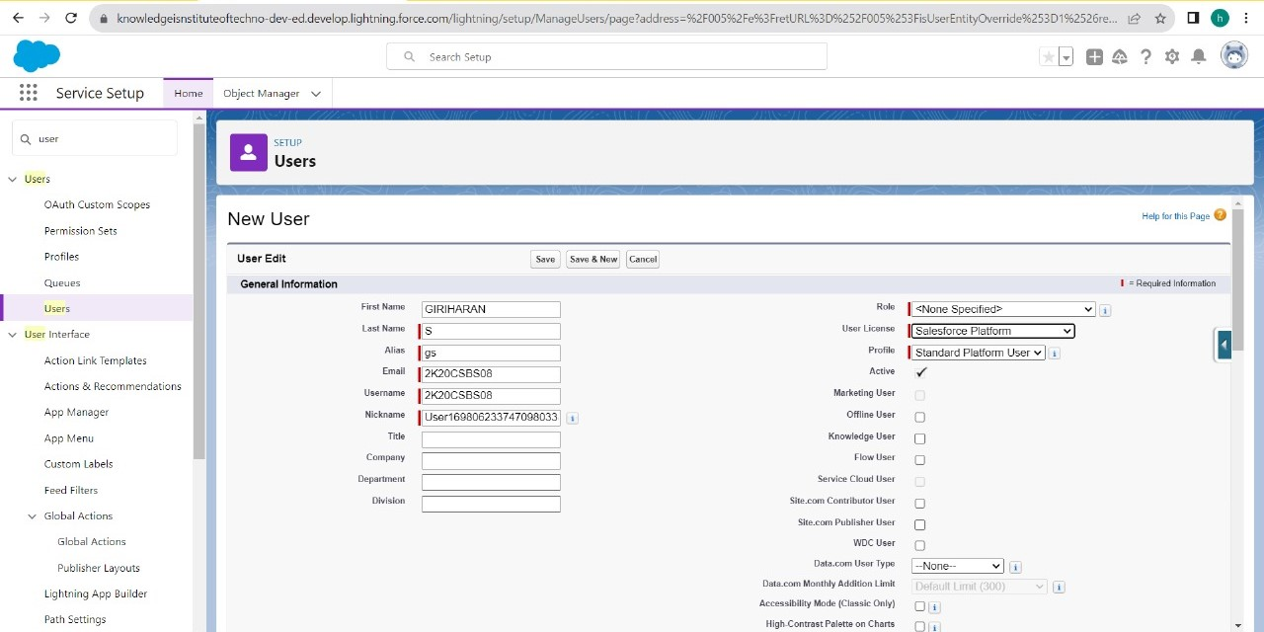

## Validation Rules

Validation rules verify that the data a user enters in a record meets the standards you specify before the user can save the record. As a crm product owner they requested to create a validation rule on account object on the phone field. 5.Then create a new role HR Manager.

**Creation Of Validation Rule**

1.Navigate to object manager and select Account object.

2.In details section scroll down and find validation rule in it.

3.Click new, give the label name and in edit error conditional formula give the formula- LEFT(Phone, 1) <> "+" .

4.In error message give the description has Phone number must begin with + (country code).

5.In error location select field.

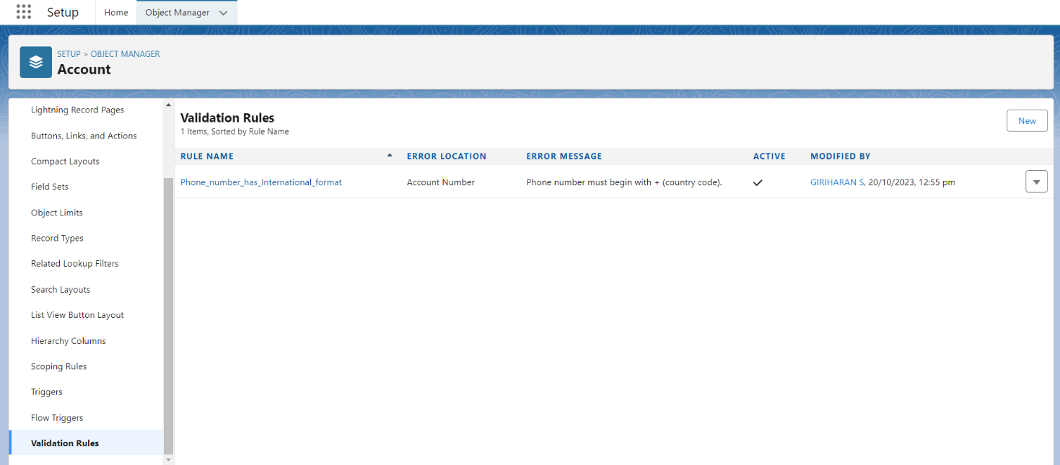

8.Click save

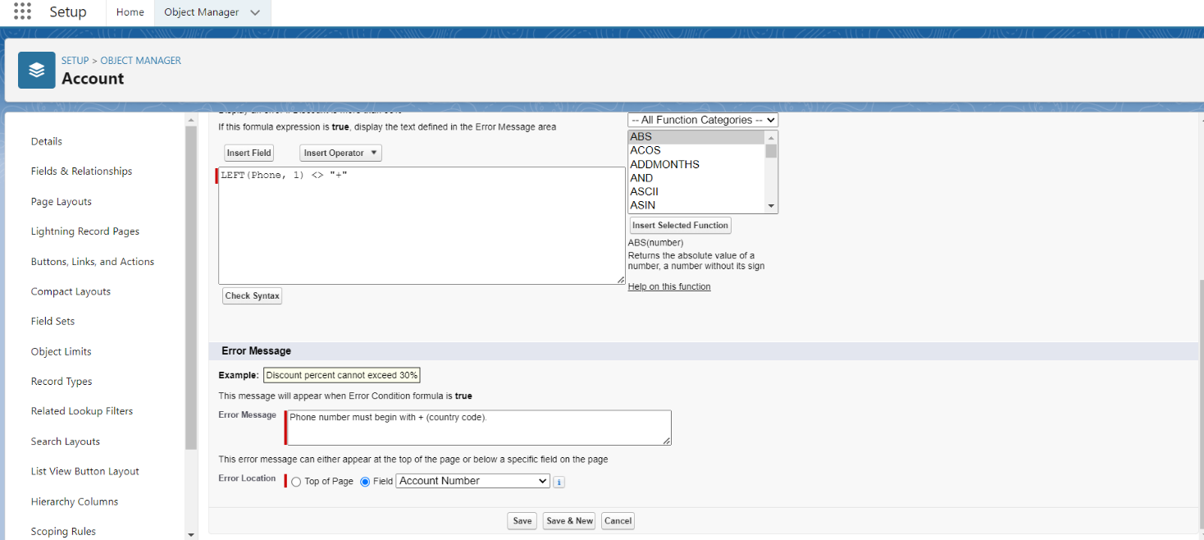

## User Adoption

1.Create Record

2.View Record

3.Delete Record

## 1)Create Record

1.Click on App Launcher on left side of screen.

2.Search Sales App & click on it.

3.Click on Sales Order tab.

4.Click new button

5.Fill all Sales Order record details.

6.Click on Save Button

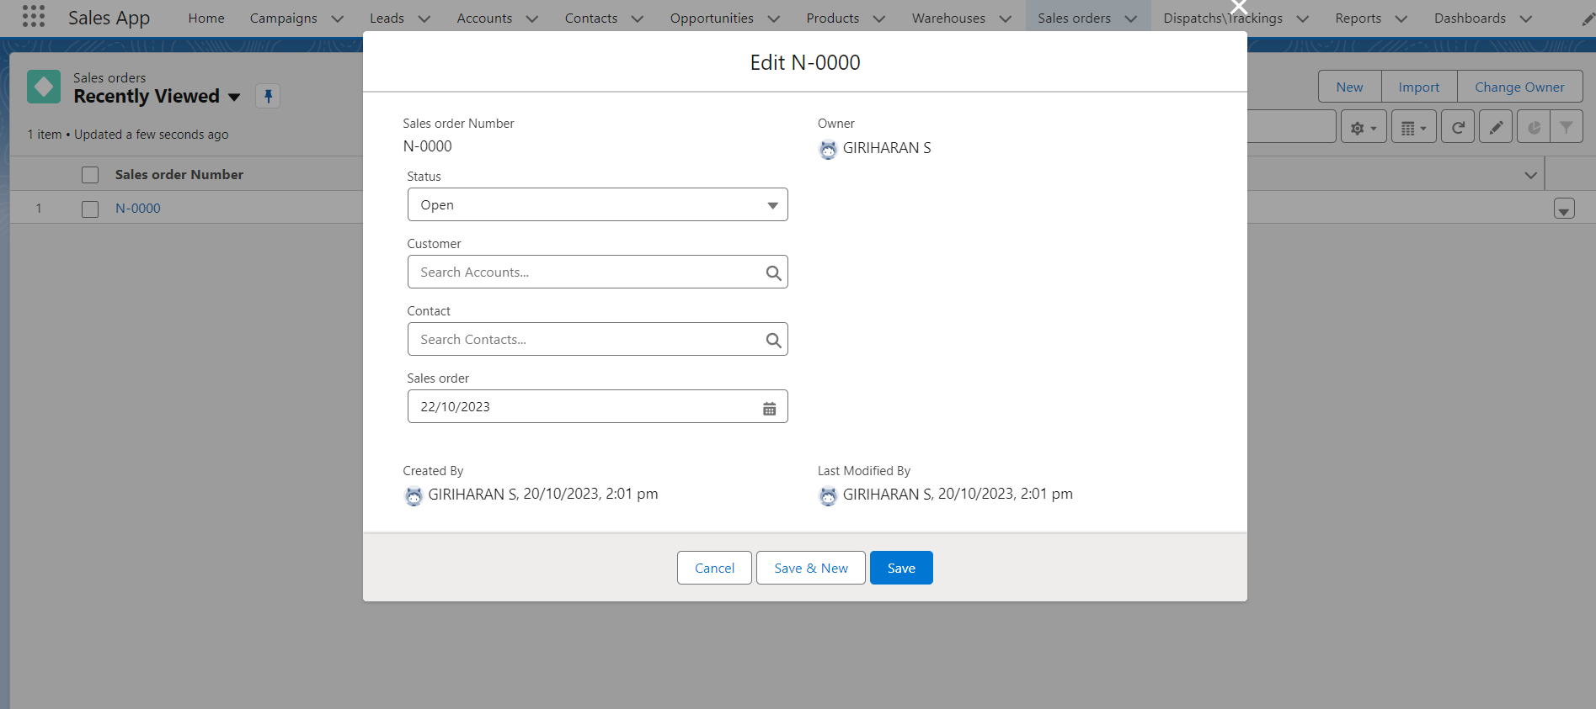

## 2)View Record

1.Click on App Launcher on left side of screen.

2.Search Sales App & click on it.

3.Click on Sales Order Tab.

4.Click on any record name. you can see the details of the Sales Order

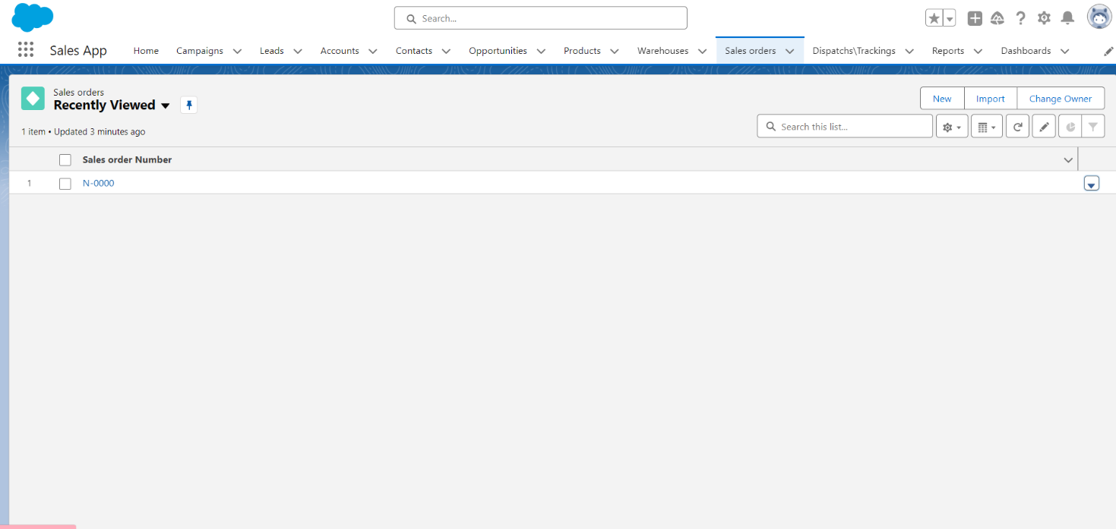

## Delete Record

1.Click on App Launcher on left side of screen.

2.Search Sales App & click on it.

3.Click on Sales Order Tab.

4.Click on Arrow at right hand side on that Particular record.

5.Click delete and delete again.

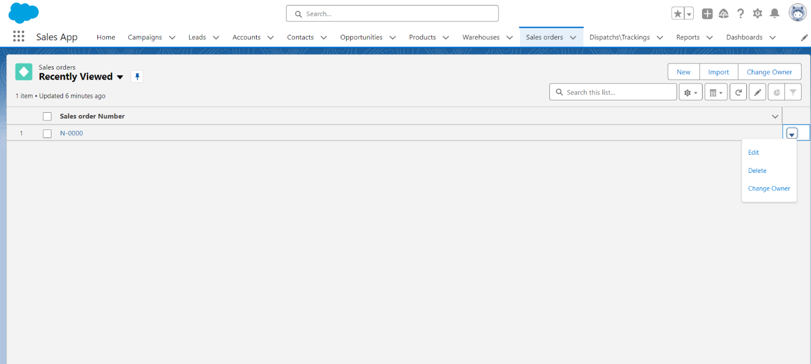

# 5.AUTOMATION

**Flow:**

Flows in Salesforce, a flow is a tool that automates complex business processes. Simply put, it collects data and then does something with that data. Flow Builder is the declarative interface used to build individual flows. Flow Builder can be used to build code-like logic without using a programming language. Flows fall into five categories:

1.Screen Flows

2.Schedule-Triggered Flows

3.Autolaunched Flows

4.Record-Triggered Flows

5.Platform Event-Triggered Flows

## 1)Create A Screen Flow

1.Click on Gear icon and select setup

2.In Quick find Box enter flow and select the flows

3.Click on New flow and Select Screen Flow.

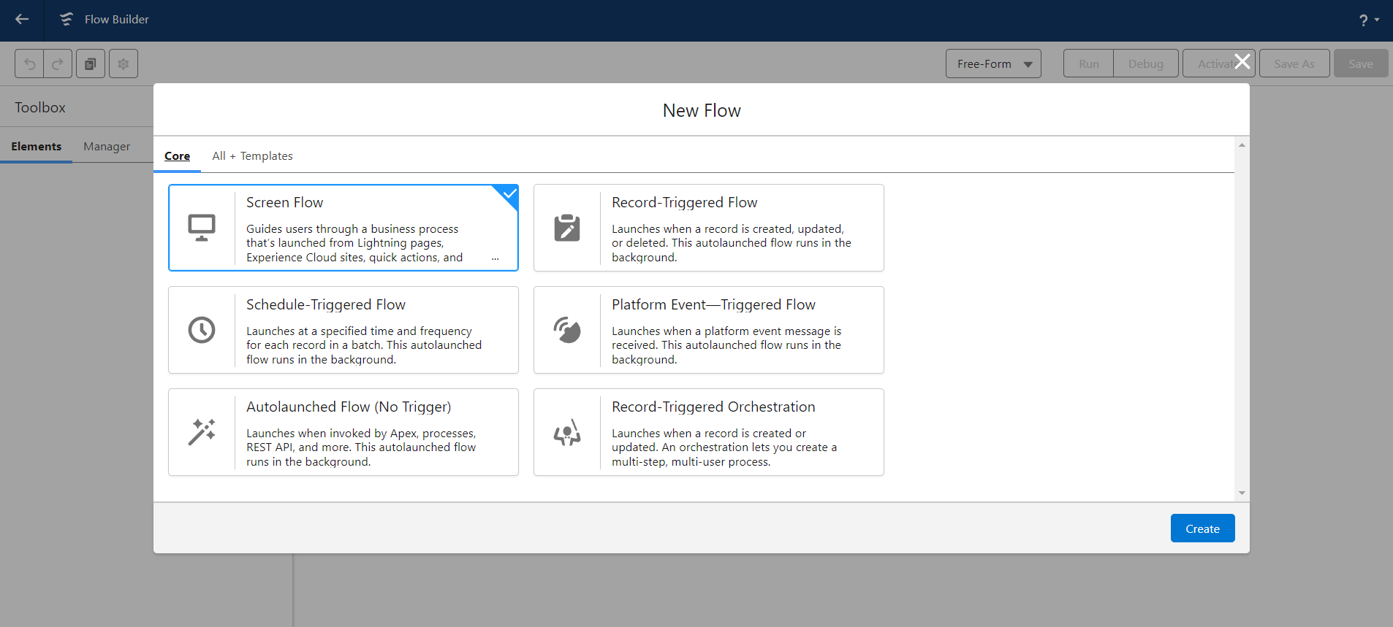

4.Select resource type has variable.

5.Give api name as Recordid.

6.Select data type as Text.

5.At bottom for Availability outside the flow check box as Available for Input.

6.Click on done.

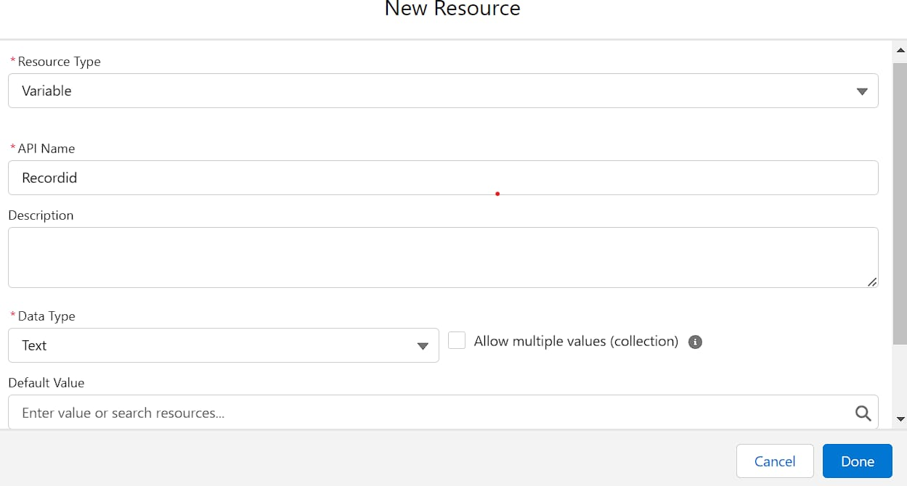

7.Now give the label name as Get Account Record

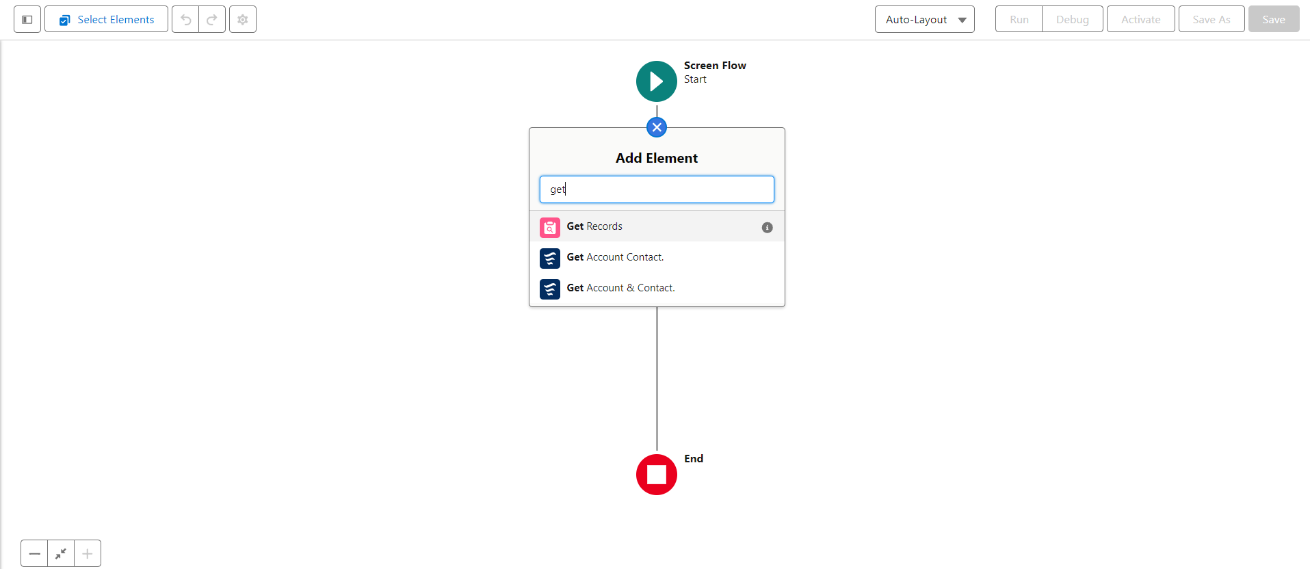

8.For Get record of object choose object as - Account

9.For Filter account records condition requirements are - All conditions are met

10.Field- Account id Operator- equals Value-Recordid (variable which we had created )

11.For how many records to share - Only the first record

12.How to store record data- Automatically stores all fields.

13.Click on done. 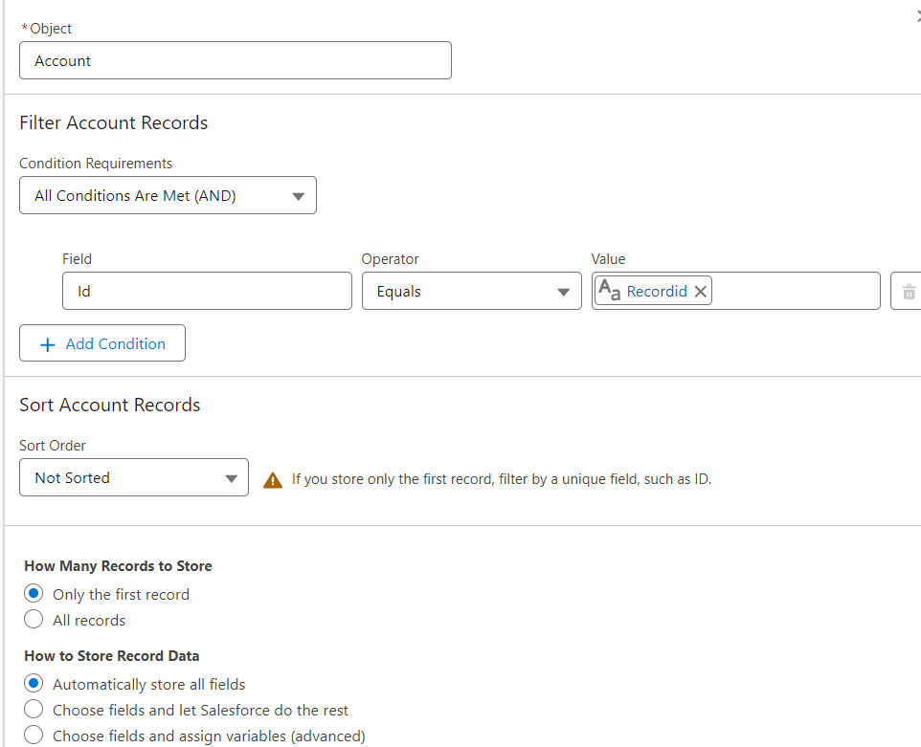

14.Now again add the element below the Get account record and select Screen as your element

15.Give the label name as Get Account & Contact.

16.Left side in the component section search for Name and drag it to the screen

17. Give the api name as Name

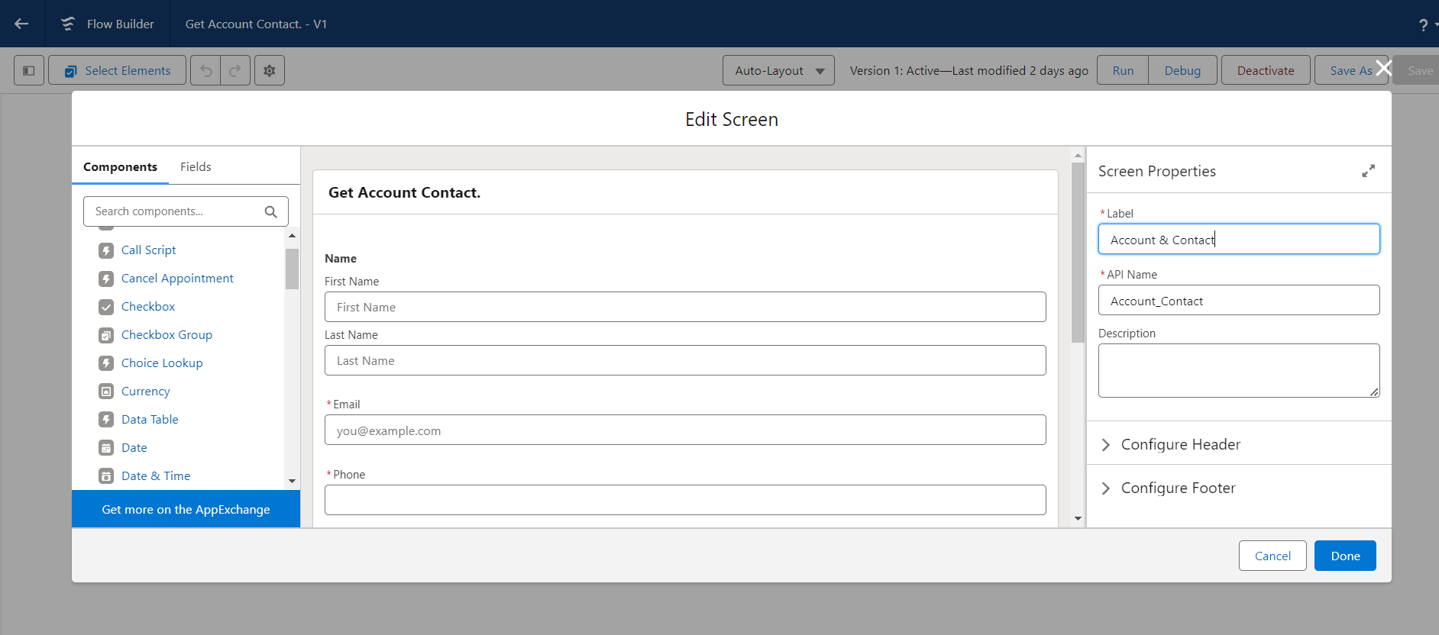

18.Now drag Email from component section and move it to the screen.

19.Give the Api name- Email Required - {!$GlobalConstant.True}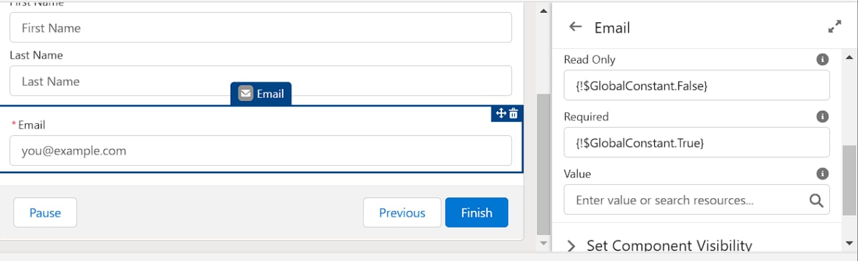

20.Now drag the Phone from component to screen below the email

21.Give the Api name as – Phone Required- {!$GlobalConstant.True}

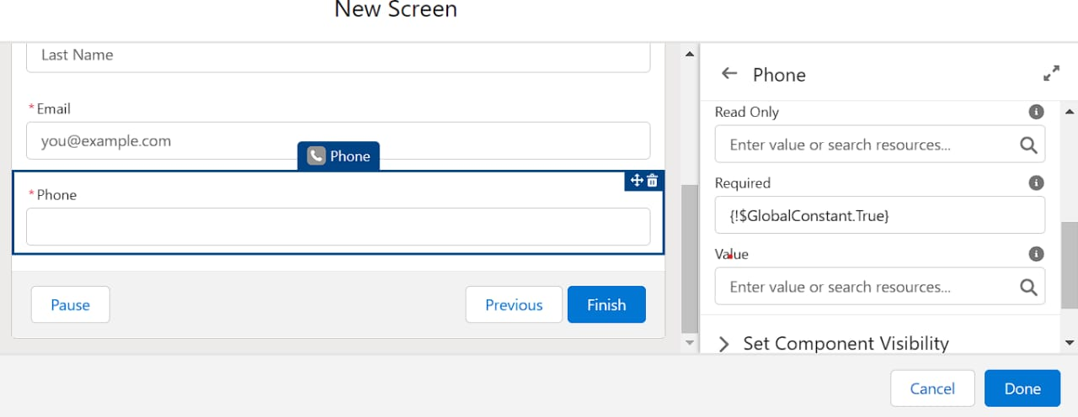

22.Now Drag Address from component section to screen .

23.Give the Api name as –Address City Value-{!Get_Account_Record.ShippingCity}

Country Value-{!Get_Account_Record.BillingCountry}

Postalcode-{!Get_Account_Record.ShippingPostalcode}

State/province value-{!Get_Account_Record.ShippingStreet}

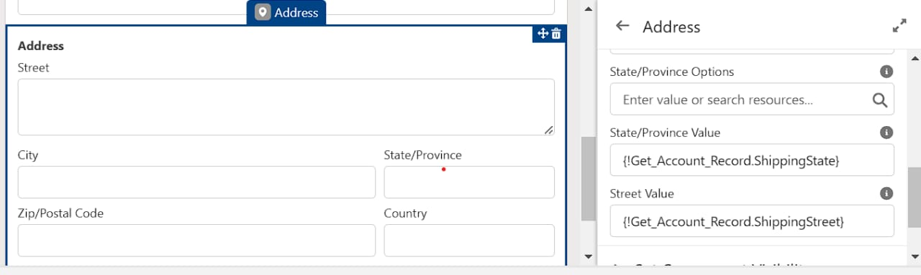

24.Click on done and save it. Give the label name as Get Account & Contact.

**To Create Lightning Home Page**

1. Click on setup gear.

2.Now search for lightning App builder.

3.And select New option

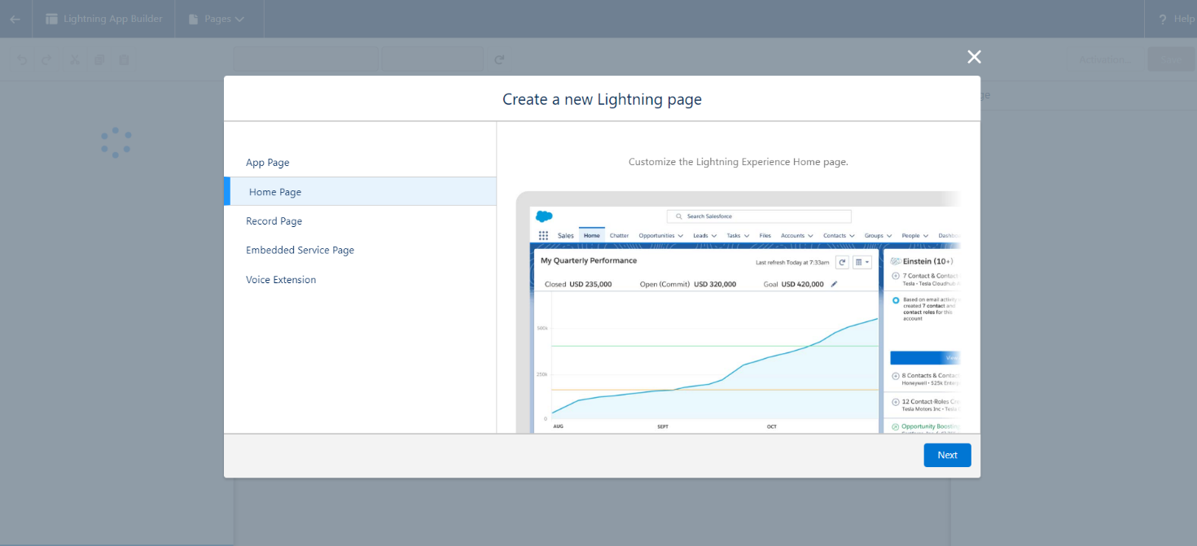4.In create a new lightning page select Home page.

5.Select Next

6.Give the label name - Account & Contact

7.Choose a standard home page.

8.Now in the component section select flow and drag down it to Corner of the page

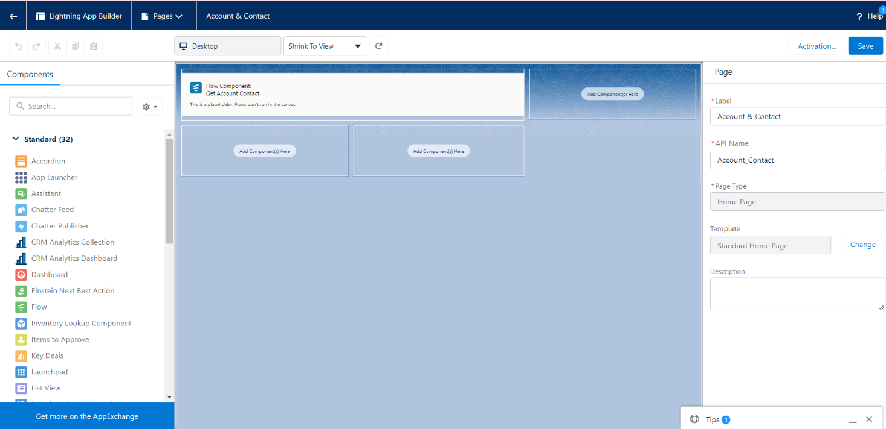

9.At the right side select the flow Get Account & Contact.

10.At the right side top of the page click on Save.

11. You will get the populate notification and click on activate.

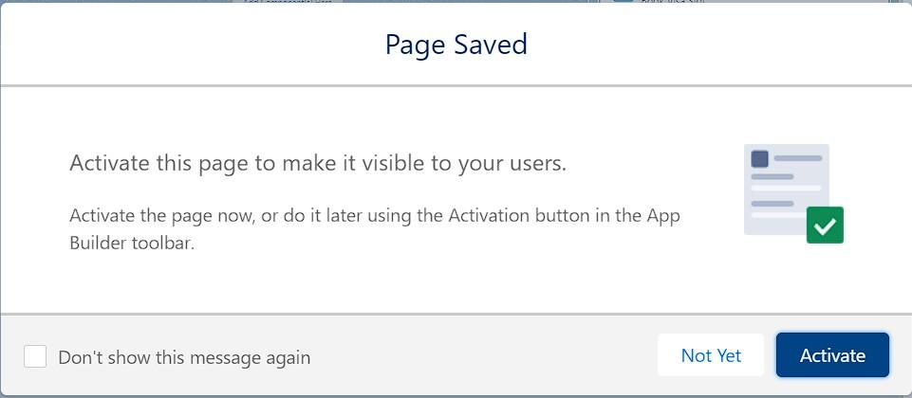

12. you will get an activation pop up select App and profile.

13. Select Sales app in lightning app selection.

14.In profiles select System administrator, Standard user, Standard platform user.

15. Save it. 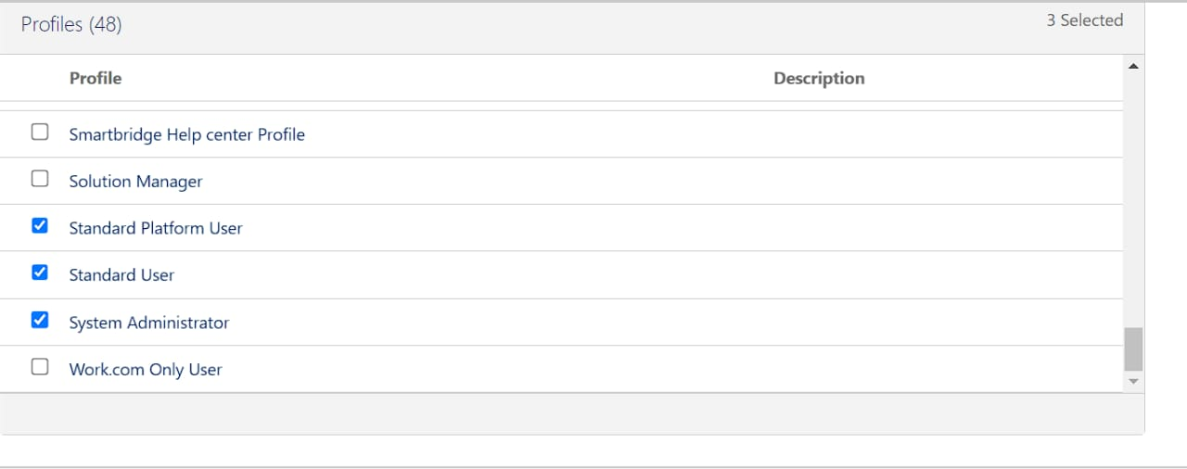

16.Now click on app launcher and search for Sales App

17.At the right side corner you can find a Pencil icon to personalize navigation click on that.

18.Click on add more items and in available items click on all and search for home.

19. Move the home page to top and click on save.

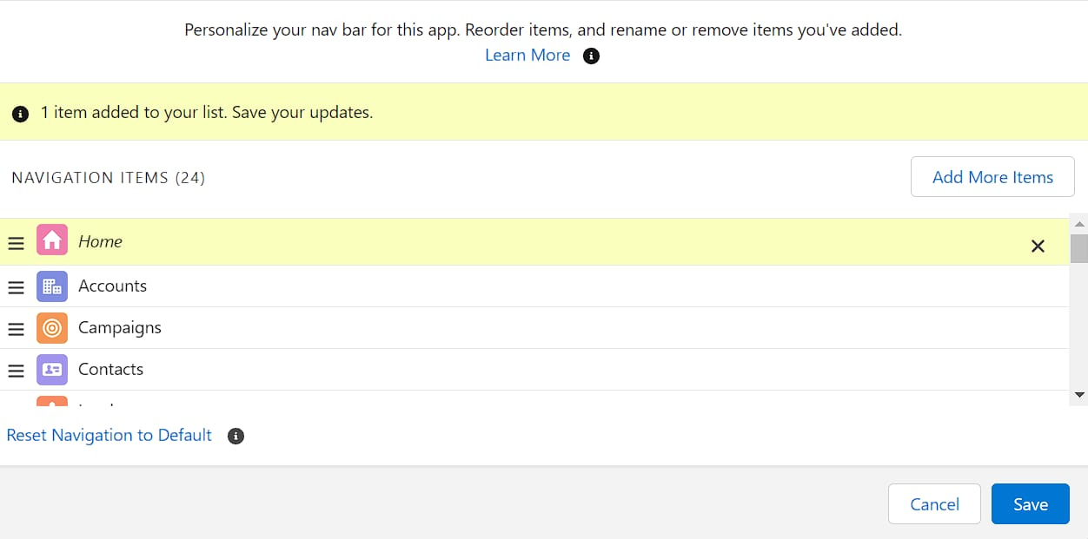

**Apex Trigger**

Apex triggers-Apex can be invoked by using triggers. Apex triggers enable you to perform custom actions before or after changes to Salesforce records, such as insertions, updates, or deletions.

A trigger is Apex code that executes before or after the following types of operations:

1.insert

2.update

3.delete

4.merge

5.upsert

6.undelete

**Create An Apex Trigger**

Use Case- when we try to create the account with the same name i.e. Preventing the users to create Duplicate Accounts.

1.Click on setup gear

2.Below the setup gear you can find developer console click on that

3.click on file and select new and select Apex trigger.

Copy this code

trigger PreventDuplicateAccounts on Account (before insert) {

Set<String> accountNames = new Set<String>();

for (Account acc : Trigger.new) {

if (accountNames.contains(acc.Name)) {

acc.addError('A duplicate account with this name already exists.');

} else {

accountNames.add(acc.Name);

}

}

}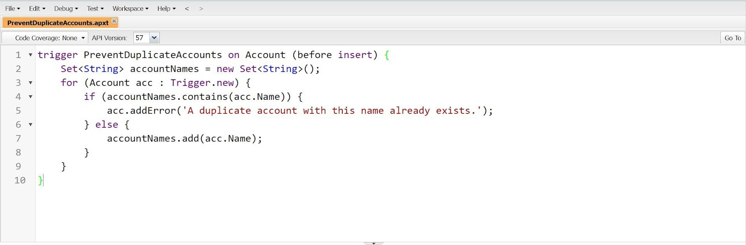

# 6.REPORTS & DASHBOARD

## Reports

A report is a list of records that meet the criteria you define. It's displayed in rows and columns, and can be filtered, grouped, or displayed in a graphical chart. Every report is stored in a folder. Folders can be public, hidden, or shared, and can be set to read-only or read/write.

## 1)Create A Report

1.Create a report that displays rating of the account and which has type and account name.

2.Click on app launcher search for reports.

3. Click the report type as Sales order with customer Click Start report.

4.Customize your report, in group rows select - Customer Account Name

5.Click refresh

6.Click save and run

7.Give report name – New Sales orders with Customer Report

8.Click Save

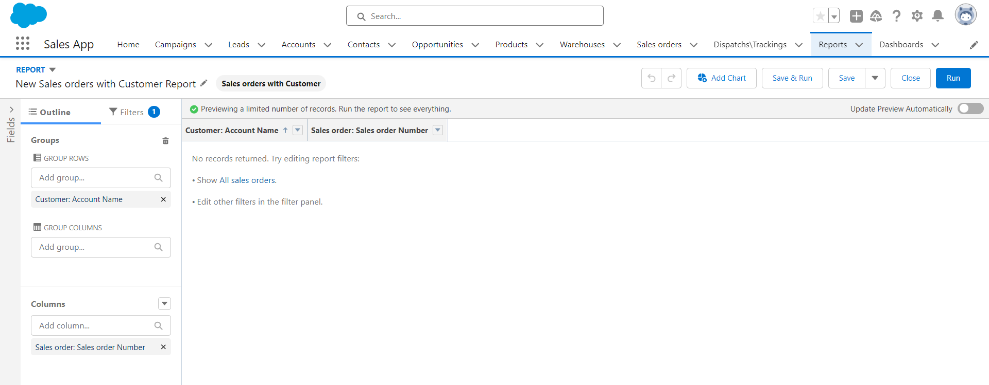

## Dashboard

Dashboards provide more insights than reports as they combine the data from many reports and show a summarized result. Looking at many reports at a time gives the flexibility of combining the results from them quickly. Also, summaries in dashboards help us decide on action plans quicker. The dashboards can contain charts, graphs and Tabular data.

## 1)Create A Dashboard

1.Click on Dashboards tab from the “Sales App” application.

2.Click on new dashboard

3.Give name- Sales App Dashboard

4.Click create

5.Give your dashboard a name and click on +component.

6.Select the New Sales orders with Customer Report which you created.

7.For the data visualization select any of the chart, table etc as your wish.

8.Click add

9.Click save

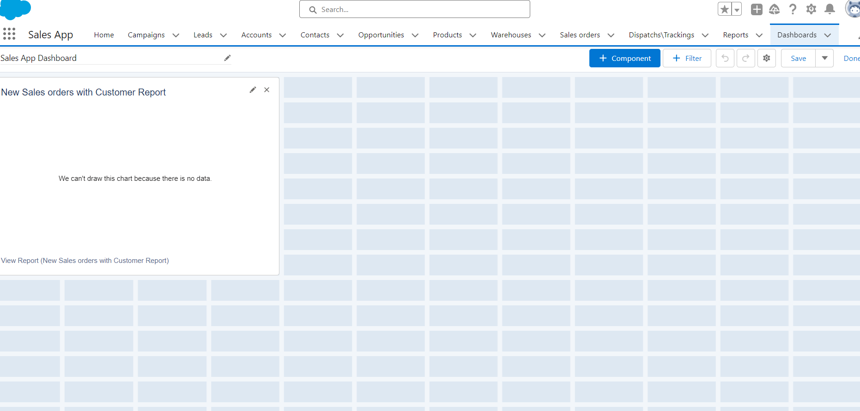

**GitHub & Project Video Demo Link** :

**GitHub Link** : https://github.com/2k20csbs08/GIRIHARAN-S

**Project Video Link** : https://drive.google.com/file/d/1OqS5r9VdJ7i7pfCBW9PAnXm9L8T5FKxi/view?usp=sharing